A picture containing clipart

Description generated with very high confidence

Hands-on

AWS Organizations Policies

AWS Solutions Architect

[**support@intellipaat.com**](mailto:support@intellipaat.com)

**+91-7022374614**

**US: 1-800-216-8930(Toll Free)**

**AWS Organizations Policies**

**Step 1:** Launch an Amazon Linux 2 instance with a custom TCP rule of port 988 open

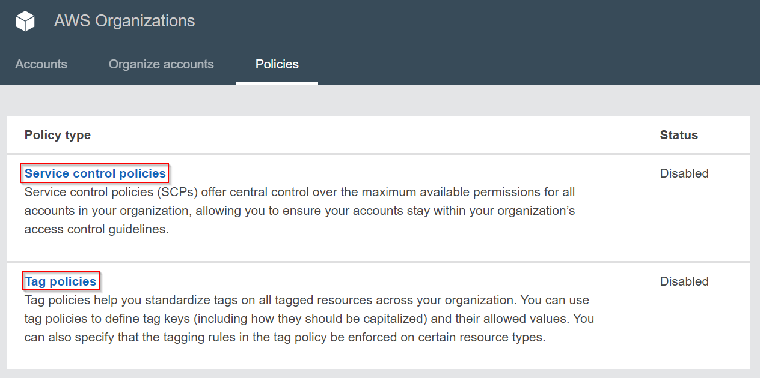

**Step 2:** To enable either one of the policies, click on Service control policies or Tag policies and enable it

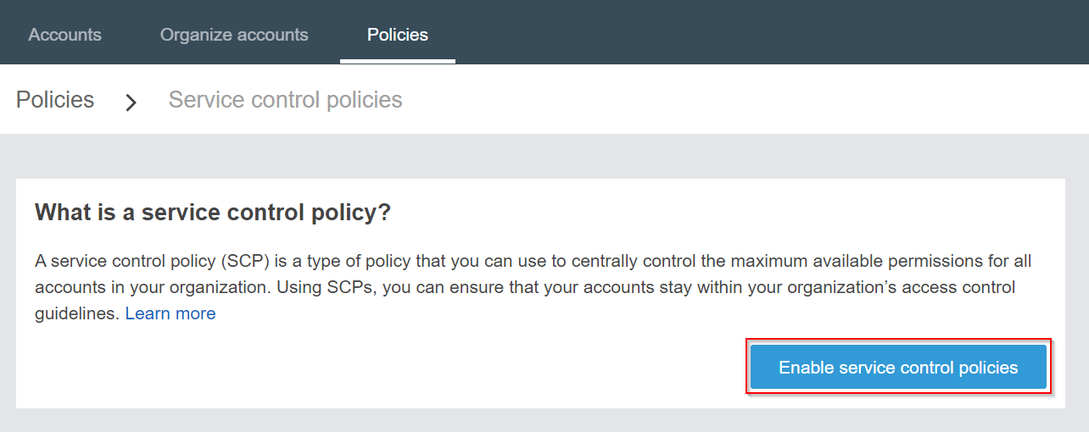

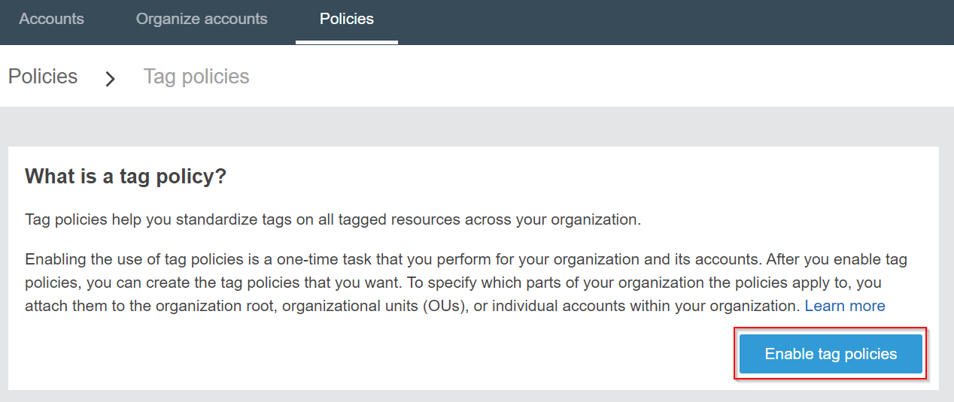

**Step 3:** After clicking the Enable button, you will get the options to create a policy

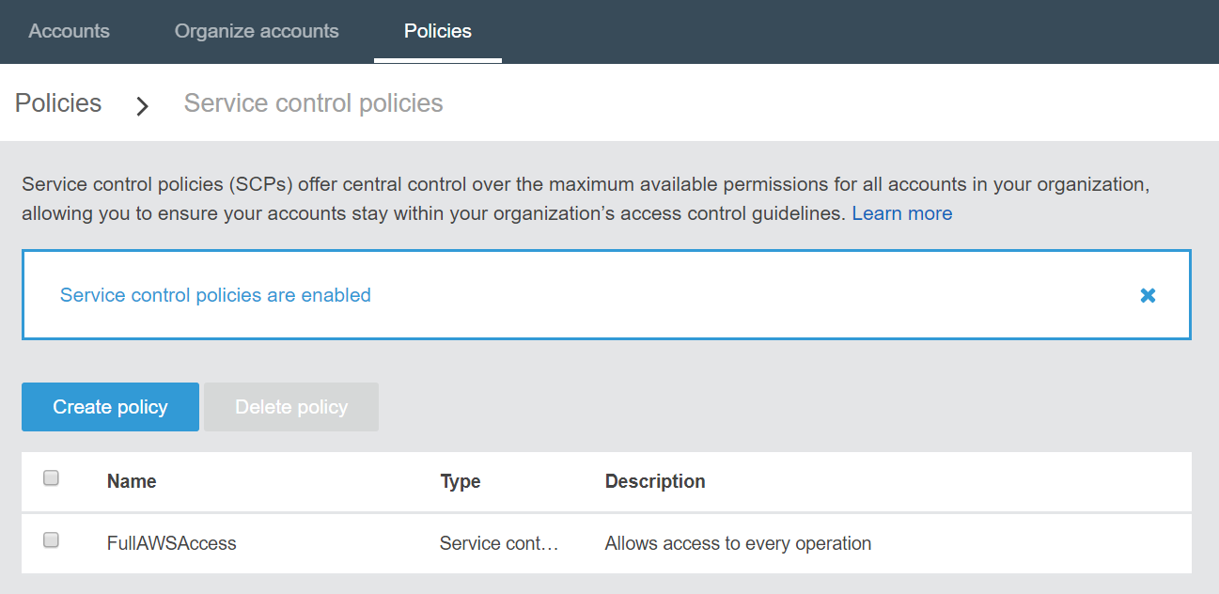

**Step 4:** Now enter a policy name. Then give a description, it is optional.

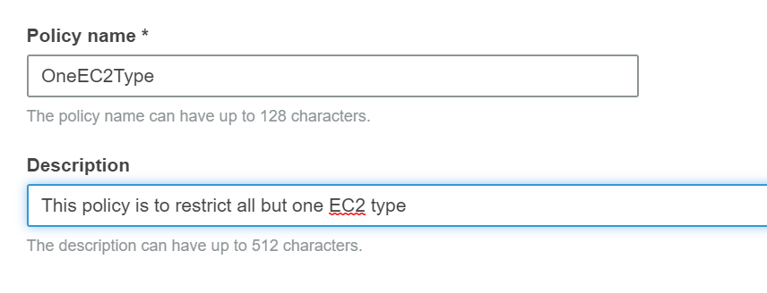

**Step 5:** Search for RDS and then choose All actions under it. After selecting it, click on Create policy.

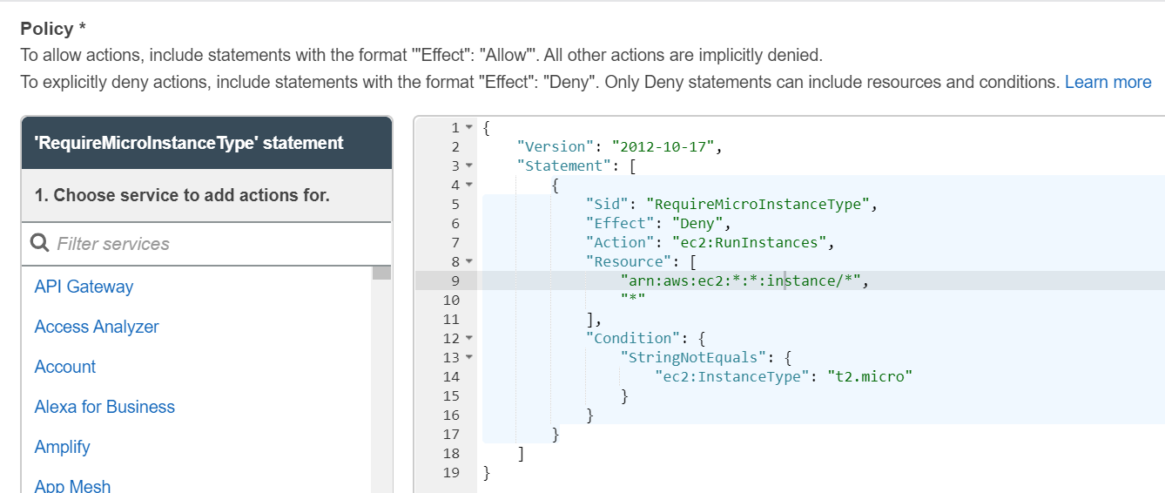

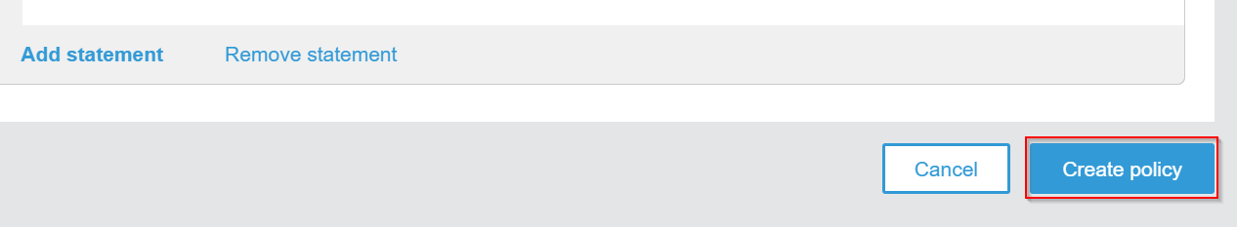

**Step 5:** We have successfully created a policy successfully

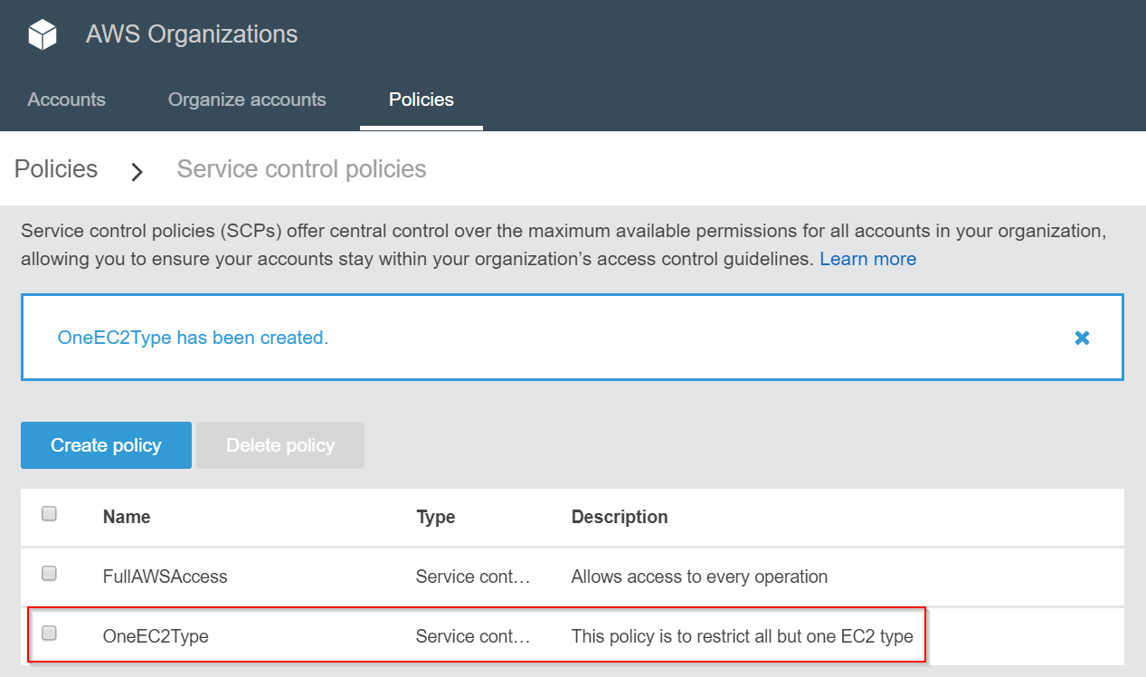

**Step 6:** Now, let’s attach this policy to the **mobile** Organizational unit and detach the FullAWSAccess policy

